**Goals selected**

Goal 11: Sustainable Cities and Communities

SDG 7: Affordable and Clean Energy).

**Problem Definition:**

Urban areas face significant challenges in providing affordable housing and managing waste effectively. The high cost of living and limited availability of housing units lead to overcrowding and social inequality, while inefficient waste management practices result in pollution and health hazards. Addressing these issues requires innovative solutions that increase affordable housing availability and improve waste management practices through policy changes, community engagement, and new technologies.

**SQL Programming**

* Data Retrieval: Write SQL queries to retrieve relevant data based on your problem definition.
* Data Analysis: Write SQL queries to analyze data and generate insights related to your SDG problem.

**Data analysis in SQL**

**Housing Availability vs. Population Growth**

You can analyze the ratio of available housing units to the population in each urban area**. This query helps you understand the availability of housing relative to the population in different urban areas. A lower ratio indicates a housing shortage**

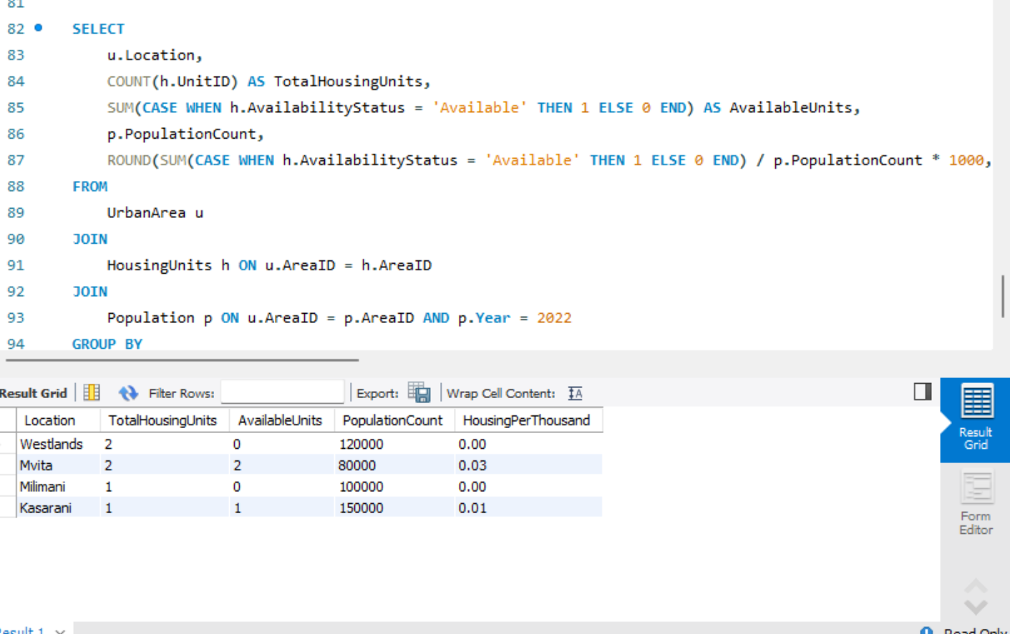

**Waste Generation vs. Housing Density**

Examine how waste generation correlates with the number of housing units in each urban area. This analysis reveals whether areas with higher housing density produce more waste, which can highlight the need for improved waste management strategies.

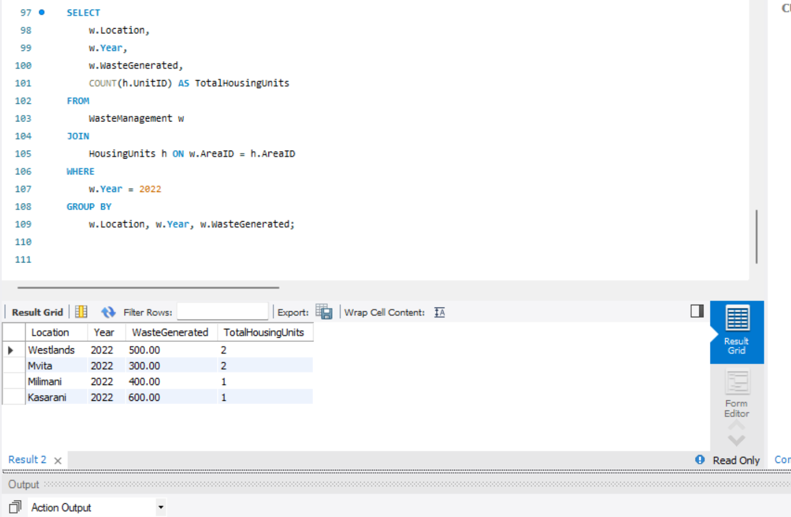

**Population Growth Impact on Housing Demand**

This output lets you see how housing availability compares to population growth over the two years. If you find that the number of available units is decreasing while the population is increasing, it might indicate a growing housing shortage in that area.

